# Project Kickoff: Data for Change

In this project, you will consider a statistical question and run through the entire data science life cycle using real data! You will also continue to learn new concepts and techniques that can help you along the way.

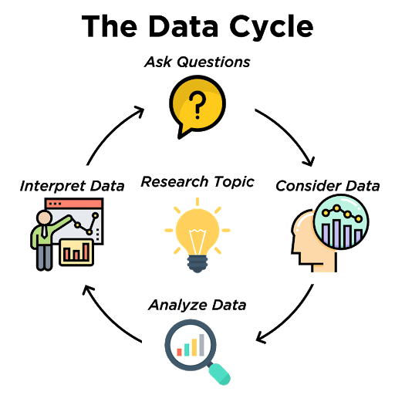

* *Ask Questions*: Formulate a statistical question that can be answered with data.
* *Consider Data*: Collect or find data that will aid in answering your question.
* *Analyze Data*: Perform statistical analysis, run calculations and/or create data displays to identify patterns and relationships
* *Interpret Data*: Answer questions and summarize the results.

Using Data in the Social Sector

Data Science can be used to discover interesting facts and figures, but it can also be used to promote change and solve problems.

Data can be collected and used to better understand a problem, to measure the scope of a problem, and to understand how people are affected by the problem.

This can all lead to supporting improvement and promoting a change to help solve the problem.

Read this article about how data was used in the Akshaya Patra Foundation in India. This foundation is a nonprofit organization working to feed children in need.

Source:

Krause, Heather. “How Using Data in the Social Sector Can Make a Difference.” *Datassist*, Datassist, 15 Aug. 2017, <https://idatassist.com/using-data-social-sector-can-make-difference/>.